Part Number: PT420-48160

Kit Contents
Item # | Quantity Reqd. | Description
1 | 1 | Emergency Assistance Kit
2
3
Hardware Bag Contents
Item # | Quantity Reqd. | Description
1 | 1 | Tether Strap
2
3
Additional Items Required For Installation
Item # | Quantity Reqd. | Description
1
2
3
Conflicts
Recommended Tools
Personal & Vehicle Protection | Notes
None
Special Tools | Notes
None
Installation Tools | Notes
None
Special Chemicals | Notes
None
General Applicability
All Lexus Vehicles
Recommended Sequence of Application
Item # | Accessory
1
2
3
*Mandatory
Vehicle Service Parts (may be required for reassembly)
Item # | Quantity Reqd. | Description
1
2
3
Legend
STOP: Damage to the vehicle may occur. Do not proceed until process has been complied with.
OPERATOR SAFETY: Use caution to avoid risk of injury.
CAUTION: A process that must be carefully observed in order to reduce the risk of damage to the accessory/vehicle and to ensure a quality installation.
TOOLS & EQUIPMENT: Used in Figures calls out the specific tools and equipment recommended for this process.
REVISION MARK: This mark highlights a change in installation with respect to previous issue.
SAFETY TORQUE: This mark indicates that torque is related to safety.

Care must be taken when installing this accessory to ensure damage does not occur to the vehicle. The installation of this accessory should follow approved guidelines to ensure a quality installation.

These guidelines can be found in the "Accessory Installation Practices" document.

This document covers such items as:-
- Vehicle Protection (use of covers and blankets, cleaning chemicals, etc.).
- Safety (eye protection, rechecking torque procedure, etc.).
- Vehicle Disassembly/Reassembly (panel removal, part storage, etc.).
- Electrical Component Disassembly/Reassembly (battery disconnection, connector removal, etc.).

Please see your Lexus dealer for a copy of this document.

NOTE: “EAK” denotes Emergency Assistance Kit

Install the Emergency Assistance Kit.
  - Remove the EAK from the package.
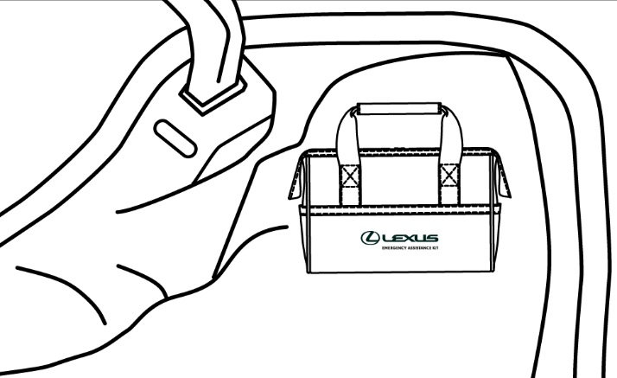
  - Place the EAK in the trunk / cargo area of the vehicle (Fig. 1-1).
Fig. 2-1
  - Use the included strap to secure the EAK to the vehicle trunk / cargo area, as applicable.

Accessory Function Checks
Confirm placement of Emergency Assistance Kit
Confirm tether strap is tightened and kit is securely in place

Vehicle Function Checks

Whenever possible, Lexus name is visible and upright
Snug strap and secure placement

Vehicle Appearance Check
After accessory installation and removal of protective cover(s), perform a visual inspection.

Ensure no damage (including scuffs and scratches) was caused during the installation process.
(For PPO installations, refer to TMS Accessory Quality Shipping Standard.)

